**Coursework report**

**Total report should be written in the pre-defined format, submitted as a PDF format and cannot exceed 7 pages.**

**Overlength reports will be penalised by 5% per page.**

1. **Give a schematic of the lowest order microwave LC filter (indicating all the L and C values) that satisfied filter design requirements.**

**Plot S11 and S21 of the microwave LC filter and comment on how this response compares with the desired filter characteristics.**

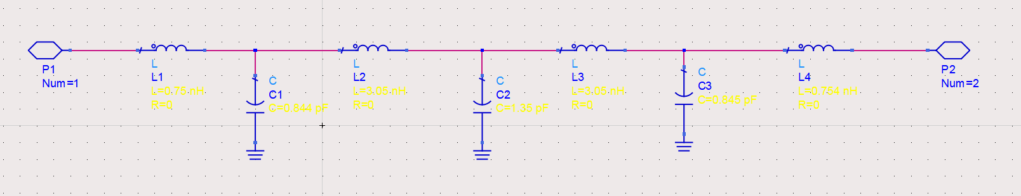

Test Unit Structure

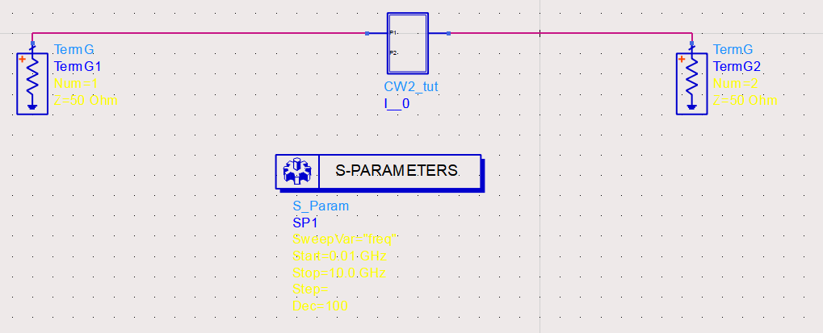

Connected Schematic

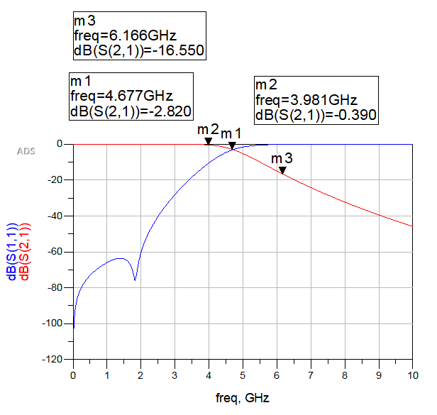

Simulation Result

Fig.A1; a) schematic of the LC microwave filter and b) S11 and S21 response of the microwave LC filter

Comments:

Cut-off frequency set around 4.7GHz, resulting a 7th order filter. The simulation result S(2,1) meets the maximum flatten criteria and also contains maximum insertion loss at 3dB round 4Gz and at least 15dB loss round 6GHz.

1. **Give a schematic of a transmission line microwave filter (indicating all the parameters of the transmission lines).**

**Plot the S21 and S11 of transmission line filter and the microwave LC filter and comment on how they compare.**

Fig.A2 a) schemativc of the transmission line filter and b) comparison of the S11 and S21 parameters of the microwave LC and transmission line filter

Comments: (no more than 100 words)

1. **Give a schematic of a microstrip microwave filter (indicating all the parameters of the microstrip lines ie widths and lenghts).**

**Plot the S21 and S11 parameters of the microstrip filter and the transmission line filter and comment on how they compare.**

Fig.A3 a) schematic of the microstrip line filter and b) comparison of the S11 and S21 parameters of the microstrip and transmission line filter

Comments: (no more than 100 words)

1. **Plot the layout of the microstrip filter indicating its overall dimensions (lenght and width)**

Fig.A4 Layout of the microstrip filter

1. **Increase the order of the filer by 1 or 2 orders. Compare the final design of the microstrip filters in terms of parameters S21 and S11 and comment on their performance, size and relative costs.**

Fig.A5 Comparison of S11 and S21 parameters of microstrip filters of the two different orders

Comments: (no more than 100 words)

1. **Explore how conductor thickness affects the response of the microstrip filter. Plot the S21 parameter of the microstrip filter for different conductor thicknesses. Assume no more than 3 different cases: zero thickness, thickness of 0.1mm and thickness of 0.5mm.**

Fig.A6 (insert text for this graph)

Comments: (no more than 100 words)

1. **Explore how conductor conductivity affects the response of the microstrip filter. Plot the S21 parameter of the microstrip filter for different conductor conductivities (no more than 4 REALISTIC conductivity values). Assume 4 different cases: ideal conductivity, conductivity of gold, copper and carbon fibre composite.**

Fig.A7 (insert text for this graph)

Comments: (no more than 100 words)